IPL 2022 Schedule, Time table, PDF, Point Table, Ranking
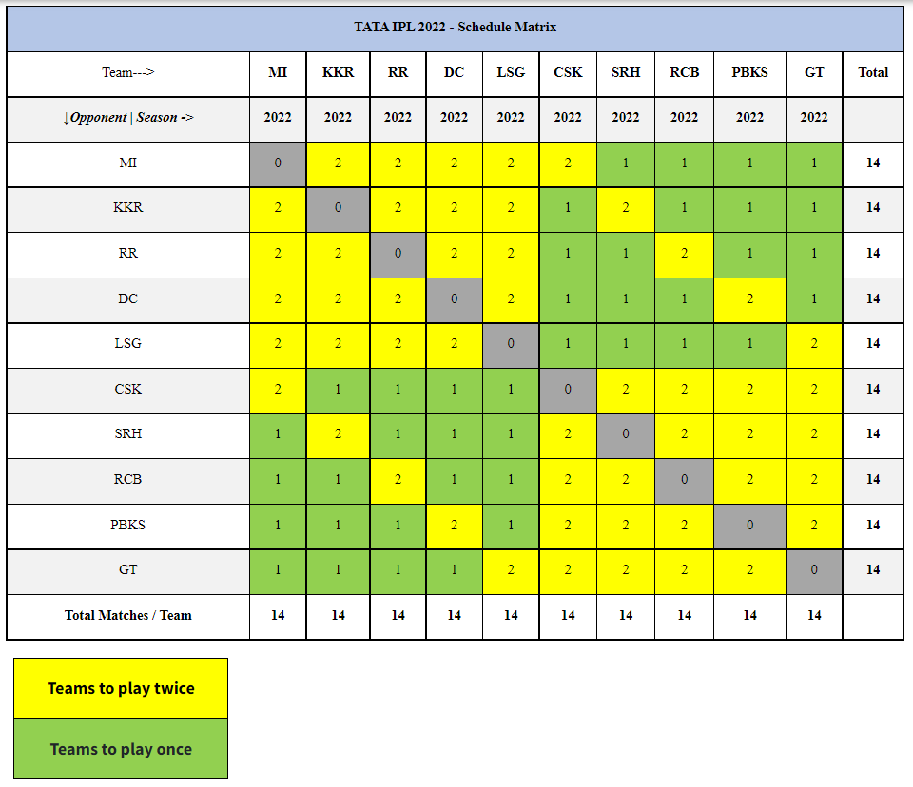

IPL Tickets Hyderabad 2022
IPL Tickets Bangalore 2022
IPL Tickets Mumbai 2022
IPL Tickets Kolkata 2022
IPL Tickets Chennai 2022
IPL Tickets Delhi 2022
IPL Tickets Rajasthan 2022
IPL Tickets Punjab 2022

